ASSIGNMENT NUMBER 2

STATEMENT: Implement a class Complex which represents the Complex Number data
type. Implement the following operations:
1. Constructor (including a default constructorwhich creates the complex number 0+0i).
2. Overloaded operator+ to add two complex numbers.
3. Overloaded operator* to multiply two complex numbers.
4. Overloaded << and &>> to print and read Complex Numbers.

AIM: To add and multiply two complex numbersusing operator overloading.

DESCRIPTION: Create a class ‘Complex’ which consists of a constructor and a default constructor
which creates the complex number. In this class, overload the respective operators to add,
multiply, read and print the complex numbers.

OOP CONCEPT USED:
1. Default constructor-:A defaultconstructor is a constructor that either has no parameters,
or if it has parameters, all the parameters have default values.
2. Operator overloading-:Operator overloading is a compile-time polymorphism in which
the operator is overloaded to provide the special meaning to the user-defined data type. Operator overloading is used to overload or redefines most of the operators available in C++. It is used to
perform the operation on the user-defined datatype.
SOURCE CODE:
#include<iostream> //including header files
using namespace std; //declaring the scope of program

class complex //class name "complex"
{
public:
float real,img; //declared variable of type float

complex() //default constructor
{
}
complex operator+ (complex);
complex operator* (complex);
friend ostream &operator<<(ostream &,complex&);
friend istream &operator<<(istream &,complex&);
};

complex complex:: operator + (complex obj)
{
complex temp;
temp.real=real+obj.real;
temp.img=img+obj.img;
return (temp);
}
istream &operator >> (istream &is,complex &obj)
{
is>>obj.real;
is>>obj.img;
return is;
}
ostream &operator<<(ostream &outt,complex &obj)
{
outt<<""<<obj.real;
outt<<"+"<<obj.img<<"i";
return outt;
}
complex complex :: operator * (complex obj)
{
complex temp;
temp.real=real*obj.real-img*obj.img;
temp.img=real*obj.img+img*obj.real;
return (temp);
}

int main()
{
complex a,b,c,d;
cout<<"\nENTER FIRST COMPLEX NUMBER\n";
cout<<"\nENTER REAL AND IMAGINARY:\t";
cin>>a;
cout<<"ENTER SECOND COMPELX NUMBER \n";
cout<<"\nENTER REAL AND IMAGINARY\t";
cin>>b;
cout<<"\n\tARITHMETIC OPERATION";
c=a+b;
cout<<"\n\tADDITION =";
cout<<c;
d=a*b;
cout<<"\n\tMULTIPLICATION=";
cout<<d;
cout<<endl;
return 0;
}
OUTPUT:
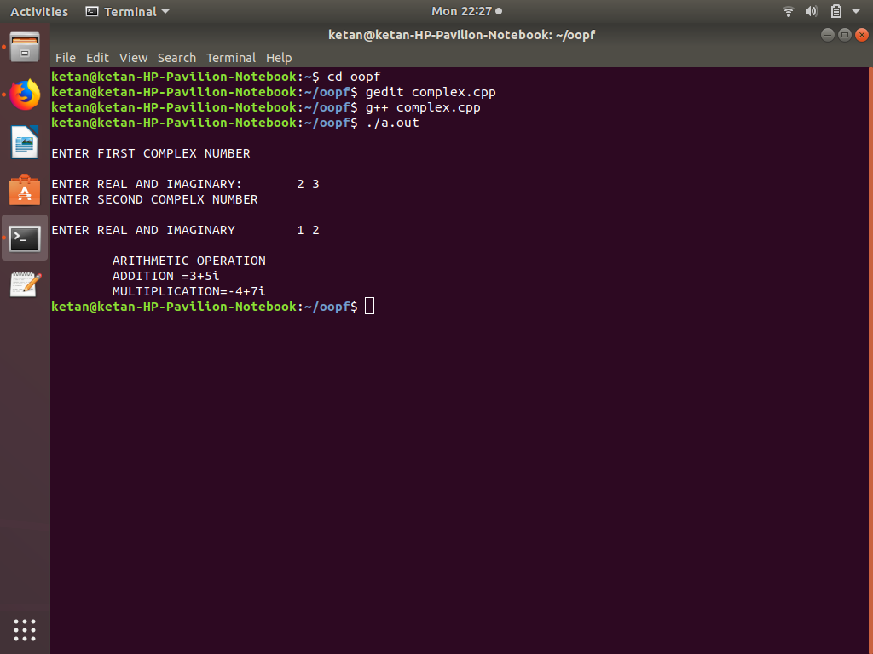

CONCLUSION: In this assignment, we learned and implemented the concept of operator overloading to add and multiply two complex numbers.

